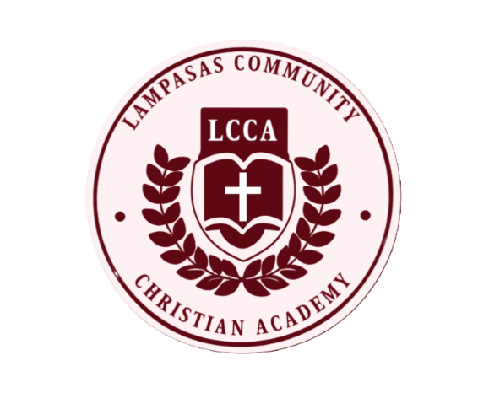
LCCA Food Allergy Plan
2025-2026

Child’s Name: ____________________________________
Child’s Allergen(s): ___________________________________
Child’s Allergic Reaction Symptoms: ____________________________________
__________________________________________________________________
__________________________________________________________________
__________________________________________________________________
Please provide a letter signed by your child’s physician and yourself with instructions to follow in the event of your child experiencing an allergic reaction.
Please provide unexpired medication to be used if an allergic reaction occurs. Medications must be in the original container and clearly labelled with your child’s full name. If your given medication is due to expire prior to its return, Lampasas Community Christian Academy will reach out to you for a replacement. Your child’s medical needs will be posted in our classroom so that all Lampasas Community Christian Academy staff will be aware of said needs.

Lampasas Community Christian Academy and its staff will not be held liable in so far as they administer medical care in conformance with the information provided on my child’s medication consent form and food allergy action plan. I understand the school and its employees will use reasonable care in doing so. All medications will be returned on the last day of school or upon the withdrawal of my child.
Parent Signature: __________________________________
Date: ____/____/________

