LCCA School Supply List 2025-2026

Please label all supplies!

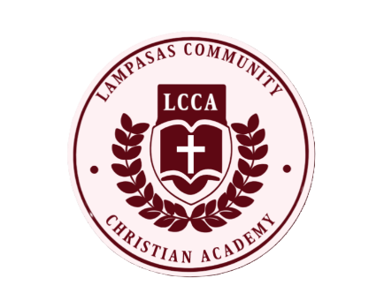

PreK3:

1 liquid glue

1 pair of scissors

1 composition notebook

1 plastic folder with pockets and brads

6 glue sticks

2 sets of watercolors

1 plastic pencil box

1 tissue box

1 cloth nap mat

Boys: manilla paper

Girls: colored construction paper

Boys: gallon Ziploc bags

Girls: quart Ziploc bags

PreK4:

1 liquid glue

1 pair of scissors

1 composition notebook

1 plastic folder with pockets and brads

6 glue sticks

2 sets of watercolors

1 plastic pencil box

1 tissue box

1 cloth nap mat

Boys: manilla paper

Girls: colored construction paper

Boys: gallon Ziploc bags

Girls: quart Ziploc bags